**Project Description:**

DentalLens is a web-based application designed to help users identify potential dental issues through image analysis. By uploading or capturing a photo of their mouth, users receive an AI-generated diagnosis detailing possible symptoms, severity, and causes of dental conditions. The system also offers personalized video recommendations, a chatbot for dental-related questions, and a calendar to track dental appointments making oral health monitoring accessible, interactive, and easy to manage for everyone.

**Requirements Summary:**

|  |  |  |
| --- | --- | --- |
|  | **MINIMUM REQUIREMENTS** | **RECOMMENDED REQUIREMENTS** |
| **OPERATING SYSTEM** | Windows 10 / macOS Mojave (10.14) or higher | Windows 11 / macOS Ventura (13) or higher |
| **PROCESSOR** | Dual-Core (Intel i3 / AMD equivalent) | Quad-Core (Intel i5 / AMD Ryzen 5 or better) |
| **RAM** | 4 GB | 8 GB or more |
| **BROWSER** | Latest version of Chrome, Firefox, or Safari | Chrome or Edge (latest stable release) |
| **DISPLAY** | 1280 x 720 resolution | 1920 x 1080 resolution or higher |
| **INTERNET** | 5 Mbps connection (Wi-Fi or LAN) | 10+ Mbps for smoother experience |
| **OTHER REQUIREMENTS** | Webcam (for image capture) or photo upload | Webcam + local file storage for uploads |

Table 1. System Requirements

To ensure accessibility across platforms, the website is optimized for both older and newer devices. The application is lightweight and web-based, requiring no intensive processing or storage. This ensures that both desktop and mobile users can interact with the system efficiently, even with limited hardware resources specified in the minimum requirements.

Overview

To ensure the prototype met its intended usability goals, a system evaluation was conducted, focusing on the core features and user experience of the Dental Lens Web Application. The evaluation was performed Face to Face.

The evaluation was structured around three main techniques and the following usability metrics:

1. Efficiency – How quickly participants could complete each task.

2. Effectiveness – Whether participants were able to correctly complete the task without

confusion.

3. Satisfaction – How comfortable and confident users felt when using the system.

Technique Used

|  |  |
| --- | --- |
| Technique | Description |
| Usability Specifications | Measuring how effectively and efficiently  users could complete key tasks |
| Heuristic Evaluation | Assessing the interface using Nielsen’s 10  Usability Heuristics |
| System Usability Scale (SUS) | A post-test survey capturing users' perceived  satisfaction and ease of use. |

Table 2: Usability Evaluation Techniques and Their Descriptions

The following are tasks to be performed by the participants in order to evaluate the

effectiveness, efficiency, and overall satisfaction of the Kitchen Sentinel prototype. These tasks:

1. Analyze the Latest Scan and the History Scan

* Open the web app and read the Latest Scan Information
* Navigate the History Scan Card and see the various records saved.

2. Use the Scan Feature

* Navigate to the Scan Page
* Provide an image of teeth
* Analyze the results given by the Convolutional Neural Network model

3. Use the Recommendations Page

* Navigate to the Recommendations Page
* Scroll through the various videos present
* Click and watch one of the videos

4. Use the Chatbot Feature

* Navigate to the Chatbot Page
* Type in a question regarding teeth health
* Read the response of the Chatbot

5. Use the Calendar Feature

* Navigate to the Calendar Page
* Press a certain date
* Create a task to be done on that date

Method of Survey and Feedback:

5 point Likert Scale Interpretation:

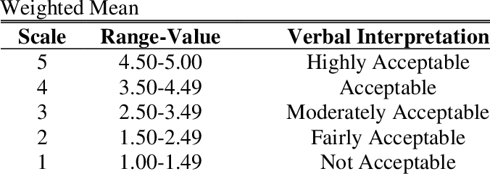

System Usability Scale (SUS) mean score:

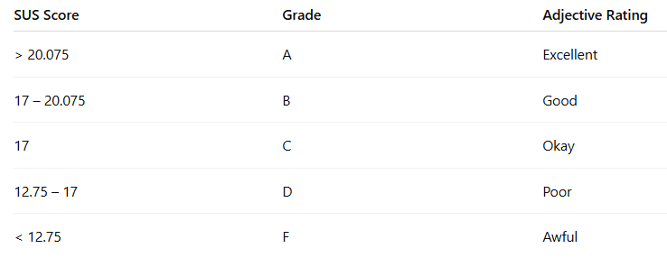

The survey was conducted face-to-face in the Mapúa Malayan Colleges Academic Building and in Matina Memorial Park.

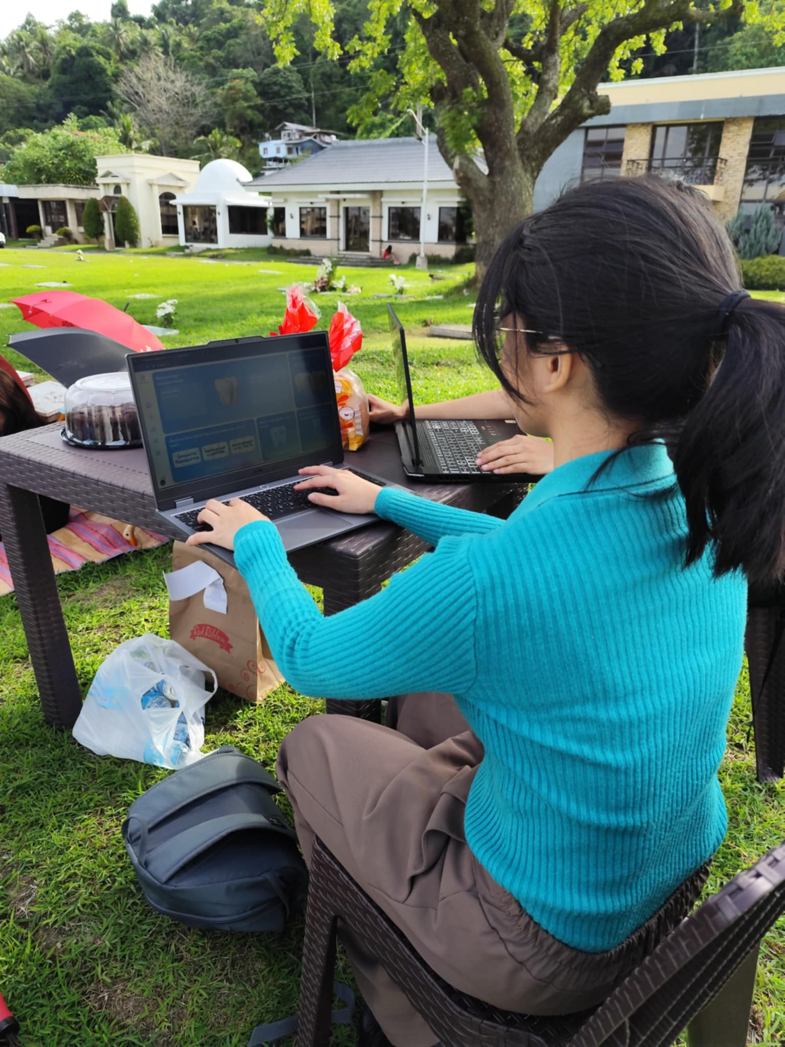

Data Presentation

Data Analysis

During the testing phase with the participants, Team GLR observed that users were generally able to engage with the web-based application smoothly. Most participants successfully completed the assigned tasks with minimal assistance, demonstrating an intuitive grasp of the system’s interface. As the testing progressed, it became evident that users quickly adapted to the flow and navigation of the application, recalling steps with ease and efficiency. Nonetheless, a few interface elements, particularly some clickable buttons, were occasionally unresponsive. Team GLR identified this as a likely result of overlooked constraint settings during the design phase, which will be addressed in future revisions.

|  |  |  |  |
| --- | --- | --- | --- |
| Task Category | Completion Mean | Interpretation | Classification |
| Main Menu Task | 0.12 min | Highly Acceptable | Very Successful |
| Image Upload Task | 0.38 min | Highly Acceptable | Very Successful |
| View Recommendation Task | 0.23 min | Highly Acceptable | Very Successful |
| Chatbot interaction Task | 0.37 min | Highly Acceptable | Very Successful |
| Calendar Scheduling Task | 0.14 min | Highly Acceptable | Very Successful |

Table 3. Task Time

Table 3 presents the results of the timed tasks conducted during the testing phase. Based on the data gathered from the participants, it was observed that they were able to complete each of the three (3) task sections with consistently efficient times. This indicates that users found the interface easy to understand and navigate, contributing to their ability to complete tasks without significant delays or confusion.

***Heuristic Evaluation***

Dental Lens prototype will be evaluated within each type of Heuristic Evaluation

*Visibility of System Status*

The system informs the participants about the status, letting users know that their actions are being processed by giving feedback.

Example:

* Completed tasks in the calendar are visibly toggled with a change in status (e.g., strikethrough, checkbox filled).
* The chatbot clearly shows when it's processing a question, which helps manage expectations.

*Match Between System and Real World*

The system uses the English language to provide effectively communication to the users of the web app. The labels and phrases can be easily understood by the users with clear intentions.

*User control and Freedom*

The system gives users flexibility and easy ways to undo or adjust actions:

* Tasks can be created, edited, completed, or deleted at any time, and changes are immediately reflected in the UI.
* There is a sidebar located on the right side that allows users to be able to easily navigate back to other pages no matter where they may be.

*Consistency and Standards*

The application attempts to follow platform and web conventions consistently, ensuring users can rely on familiar patterns throughout their interaction. The scan page, calendar, and task system use consistent visual styles, layouts, and terminology (e.g., “Scan,” “Result,” “Task”).

*Error Prevention*

User interaction with the system faced almost no errors and did not hinder user experience with completing the tasks.

*Recognition rather than recall*

The application minimizes the user’s memory load by presenting relevant information at the point of need. For example, previously scanned dental records are listed in the scan history card and users can press these in order to see the various specific details of a scan. The latest prediction results are also persistently shown without requiring users to re-upload or re-navigate. The calendar auto-populates scheduled tasks by date, eliminating the need to manually recall scheduled events.

*Flexibility and Efficiency of Use*

Frequent actions like scanning, viewing results, and accessing educational videos are streamlined through intuitive UI components and accessible buttons. The program also provides a description of the disease as well as symptoms and causes, reducing the need for users to use a separate search engine to learn more about a disease.

*Aesthetic and Minimalistic Design*

The UI design uses a clean and consistent layout, supported by Tailwind CSS for spacing, alignment, and modern visuals. Key information like scan results, task lists, and recommendations are displayed without clutter, prioritizing readability and focus.

*Help Users Recognize, Diagnose, and Recover from Errors*

Error states, such as invalid scan uploads, are clearly indicated. For instance, if an image is not dental-related, a specific prompt like “Invalid image: Please upload a clear image of an actual teeth” is shown.

*Help and Documentation*

Task Descriptions are available in the Home Page where each card has a title description which could describe what features are present in the web app pages.

*Heuristics Conclusion*

The system attempts to adhere to Nielsen’s usability heuristics. It emphasizes recognition, and balances clarity with functionality. Minor improvements could be made in providing more explicit guidance for first-time users or clearer feedback during less common failure cases (e.g., network issues). Overall, the app demonstrates usability principles that are tailored to the healthcare context and the task management needs of its users.

***Participant Survey and Feedback***

The table presents the survey results collected after the testing phase. The data indicates that the prototype is currently at an acceptable level of quality and is considered successful overall. However, the team plans to further improve specific areas to improve user experience. Evaluated against the 10 Usability Heuristics, the results suggest that the prototype met participant expectations.

**Average Scores Summary**

|  |  |  |  |
| --- | --- | --- | --- |
| **Category** | **Average Score** | **Interpretation** | **Classification** |
| Effectiveness | 4.68 | Highly Acceptable | Very Successful |
| Efficiency | 4.72 | Highly Acceptable | Very Successful |
| Overall Satisfaction | 4.77 | Highly Acceptable | Very Successful |
| Overall Average | 4.72 | Highly Acceptable | Very Successful |

The table presents users' evaluations of the Dental Lens prototype across three areas: effectiveness (4.68), efficiency (4.72), and overall satisfaction (4.77). The average score is 4.72, reflecting consistent interpretation and classification. This indicates that users perceived the prototype as effective, efficient, and generally satisfactory.

**System Usability Scale (SUS) Survey**  
 After completing the initial questionnaire, participants were asked to fill out the System Usability Scale (SUS) survey. The scores of each participant are presented below.

**Results**

|  |  |  |
| --- | --- | --- |
| **Participant** | **Score** | **Interpretation** |
| **P1** | **15** | **A** |
| **P2** | **24** |
| **P3** | **22** |
| **P4** | **23** |
| **P5** | **25** |
| **P6** | **25** |
| **P7** | **25** |
| **P8** | **25** |
| **P9** | **23** |
| **P10** | **25** |
| **SUS Mean Score** | **23.2** |

Feedback

While the majority of the feedback was highly positive, some comments were directed toward specific areas for improvement. One of the features to be enhanced as the design of the UI. These concerns are to be implemented along with other suggestions to improve the overall user experience.

**Critique and Summary:**

What were the advantages and disadvantages of your evaluation?

Our survey was comprised of a 5-point Likert Scale:

* **Simplicity and Clarity:**  
   The 5-point Likert scale is easy for respondents to understand and answer, which likely improved the response rate and accuracy.
* **Quantifiable Data:**  
   It allowed us to gather measurable data that could be easily analyzed statistically to identify trends and user satisfaction levels.
* **Balanced Response Options:**  
   The scale provided a neutral midpoint, allowing participants to express neutrality when appropriate, which can reduce forced choices.
* **Comparability:**  
   Using a standardized scale made it easier to compare responses across different questions and respondents.

What would you have done differently knowing what you know now (both design wise and evaluation-wise)? Given more resources, what could you have done that would have produced significantly more insightful evaluation results (again, whether this is an improved prototype or a different evaluation path).

* Having the knowledge we have now, we could have made the chatbot a universal feature where it could assist users and explain the various features as well as the needed inputs to help them in every step of the process. Also, if they encounter an error, it would be helpful if the chatbot could explain the error for the users and help them on how to do certain processes correctly.

Summary of the Project:

The results of the evaluation showed high user success rates across all tasks, with minimal errors or confusion. Participants found the interface intuitive and were able to complete tasks such as scanning, viewing recommendations, using the chatbot, and managing tasks on the calendar efficiently. Average task completion times were low, indicating strong usability and system responsiveness.

The heuristic evaluation confirmed that the system followed most established usability principles, such as visibility of system status, consistency, error prevention, and minimalistic design. Although there are minor issues such as difficulty for new users to determine what the sidebar icons represented.

Post-task surveys using a **5-point Likert Scale** and the **System Usability Scale (SUS)** indicated that users perceived the system as highly effective and satisfactory, with an overall average score of **4.72** across all usability categories. While SUS scores were moderate (average: 23.2), qualitative feedback suggested the UI could be further improved, particularly in terms of layout polish and in-app guidance.

The evaluation approach had several strengths, including its simplicity, measurable results, and high response accuracy due to the intuitive nature of the Likert scale. However, it also had limitations in terms of depth—quantitative data did not always capture the reasons behind user choices, and some features such as the chatbot could have offered more contextual support.

In hindsight, improvements such as integrating a more intelligent, context-aware chatbot, refining the visual design, and expanding user guidance features would lead to a significantly enhanced user experience. Despite these areas for growth, the current iteration of DentalLens successfully demonstrates its goal of making dental health monitoring more interactive, accessible, and user-centered.